7. SIGNAL RECONSTRUCTION AND SPECTRAL ANALYSIS

Experiment 7.1
Reconstruction of Signal from Samples (Ideal Interpolation)
Aim
Reconstruct a bandlimited signal using sinc interpolation.
Apparatus Required
Program (MATLAB)
% Reconstruction of Signal from Samples
clc;
clear;
close all;
% Original signal frequency
fm = 5; % Hz
% Sampling frequency
fs = 25; % Hz
% Continuous-time signal
t = 0:0.001:1;
x = sin(2*pi*fm*t);
% Sampling
ts = 0:1/fs:1;
xs = sin(2*pi*fm*ts);
% Reconstruction using interpolation
xr = interp1(ts,xs,t,'spline');
% Plotting
figure;
subplot(3,1,1);
plot(t,x,'LineWidth',2);
grid on;
title('Original Signal');
xlabel('Time (s)');
ylabel('Amplitude');
subplot(3,1,2);
stem(ts,xs,'filled');
grid on;
title('Sampled Signal');
xlabel('Time (s)');
ylabel('Amplitude');
subplot(3,1,3);
plot(t,xr,'LineWidth',2);
grid on;
title('Reconstructed Signal');
xlabel('Time (s)');
ylabel('Amplitude');
Output Generated Graph
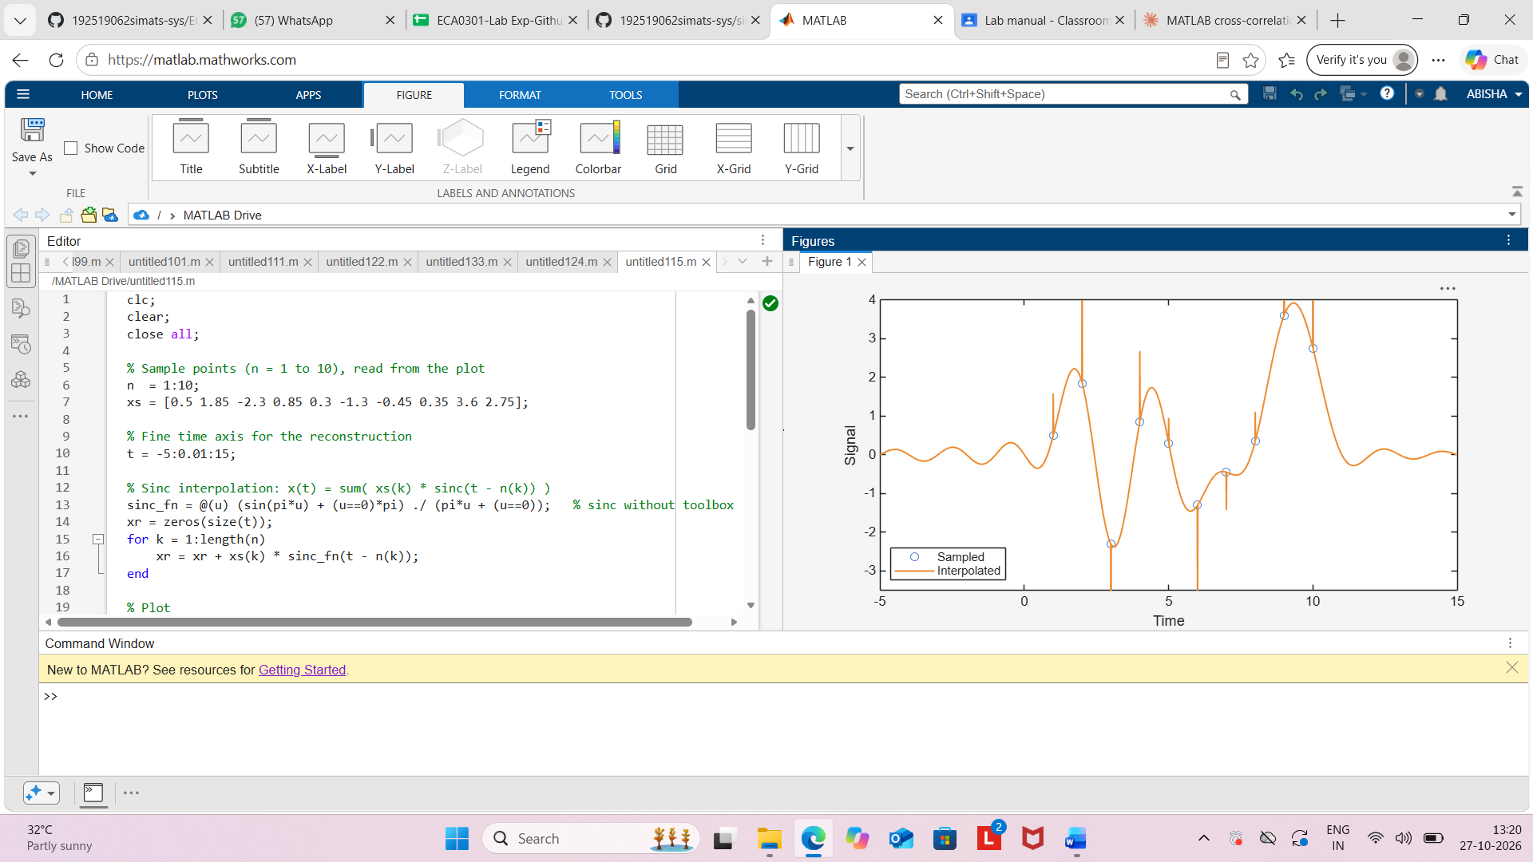
Result
The sinusoidal signal was sampled at 25 Hz, which is greater than the Nyquist rate of 10 Hz. Using interpolation, the original signal was reconstructed successfully, demonstrating accurate signal recovery from its samples in accordance with the Sampling Theorem.

